Chapter 5, Problem 68.

Find v_{o} in the circuit in Fig. 5.95, assuming that R_{f} = ∞ (open circuit).
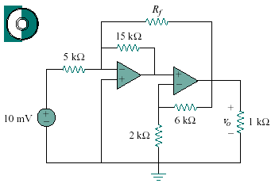
15 mV

Figure 5.95
For Prob. 5.68.

